Project Design Phase-I

Solution Architecture

Date | 20 October 2023
Team ID | NM2023TMID01648
Project Name | CLIMATE TRACK SMART
Maximum Marks | 4 Marks

Solution Architecture:

The solution architecture for ClimateTrack involves several key components and technologies to ensure the effective tracking and management of climate-related data. Here is an overview of the architecture:
1. User Interface: ClimateTrack includes a user-friendly interface that allows stakeholders to interact with the platform. This interface enables users to input and access climate data, view analytics, and manage their climate-related activities.
2. Blockchain Network: The core of ClimateTrack's architecture is a blockchain network. This network consists of distributed nodes that store and validate climate data using cryptographic algorithms. It ensures data integrity, immutability, and transparency, making it resistant to tampering or unauthorized modifications.
3. Smart Contracts: ClimateTrack utilizes smart contracts, which are self-executing agreements with predefined rules and conditions. These contracts automate the execution of climate-related agreements, such as carbon offset transactions or renewable energy certificates. Smart contracts ensure transparency, accuracy, and efficiency in executing climate-related activities.
4. Data Storage and Integration: ClimateTrack integrates with various data sources, such as IoT devices, weather APIs, and existing climate databases. These sources provide real-time and historical climate data, which is securely stored on the blockchain network. Integration with external systems allows for comprehensive data collection and analysis.

5. Analytics and Reporting: ClimateTrack incorporates analytics and reporting capabilities to provide insights into climate-related data. It includes data visualization tools, statistical analysis, and reporting functionalities to help stakeholders monitor progress, identify trends, and make informed decisions regarding climate actions.
6. Security and Access Control: To ensure data security, ClimateTrack implements robust encryption mechanisms and access control protocols. Only authorized users can access and modify specific data based on their roles and permissions. This ensures data privacy and prevents unauthorized access to sensitive climate information.
7. Scalability and Interoperability: ClimateTrack is designed to be scalable and interoperable with other systems and platforms. It can handle a large volume of climate data and accommodate future growth. Interoperability allows seamless integration with existing climate initiatives, enabling collaboration and data exchange between different stakeholders.
Overall, the solution architecture of ClimateTrack combines blockchain technology, smart contracts, data integration, analytics, security measures, and scalability to create a comprehensive platform for tracking and managing climate-related data effectively.
Example - Solution Architecture Diagram:

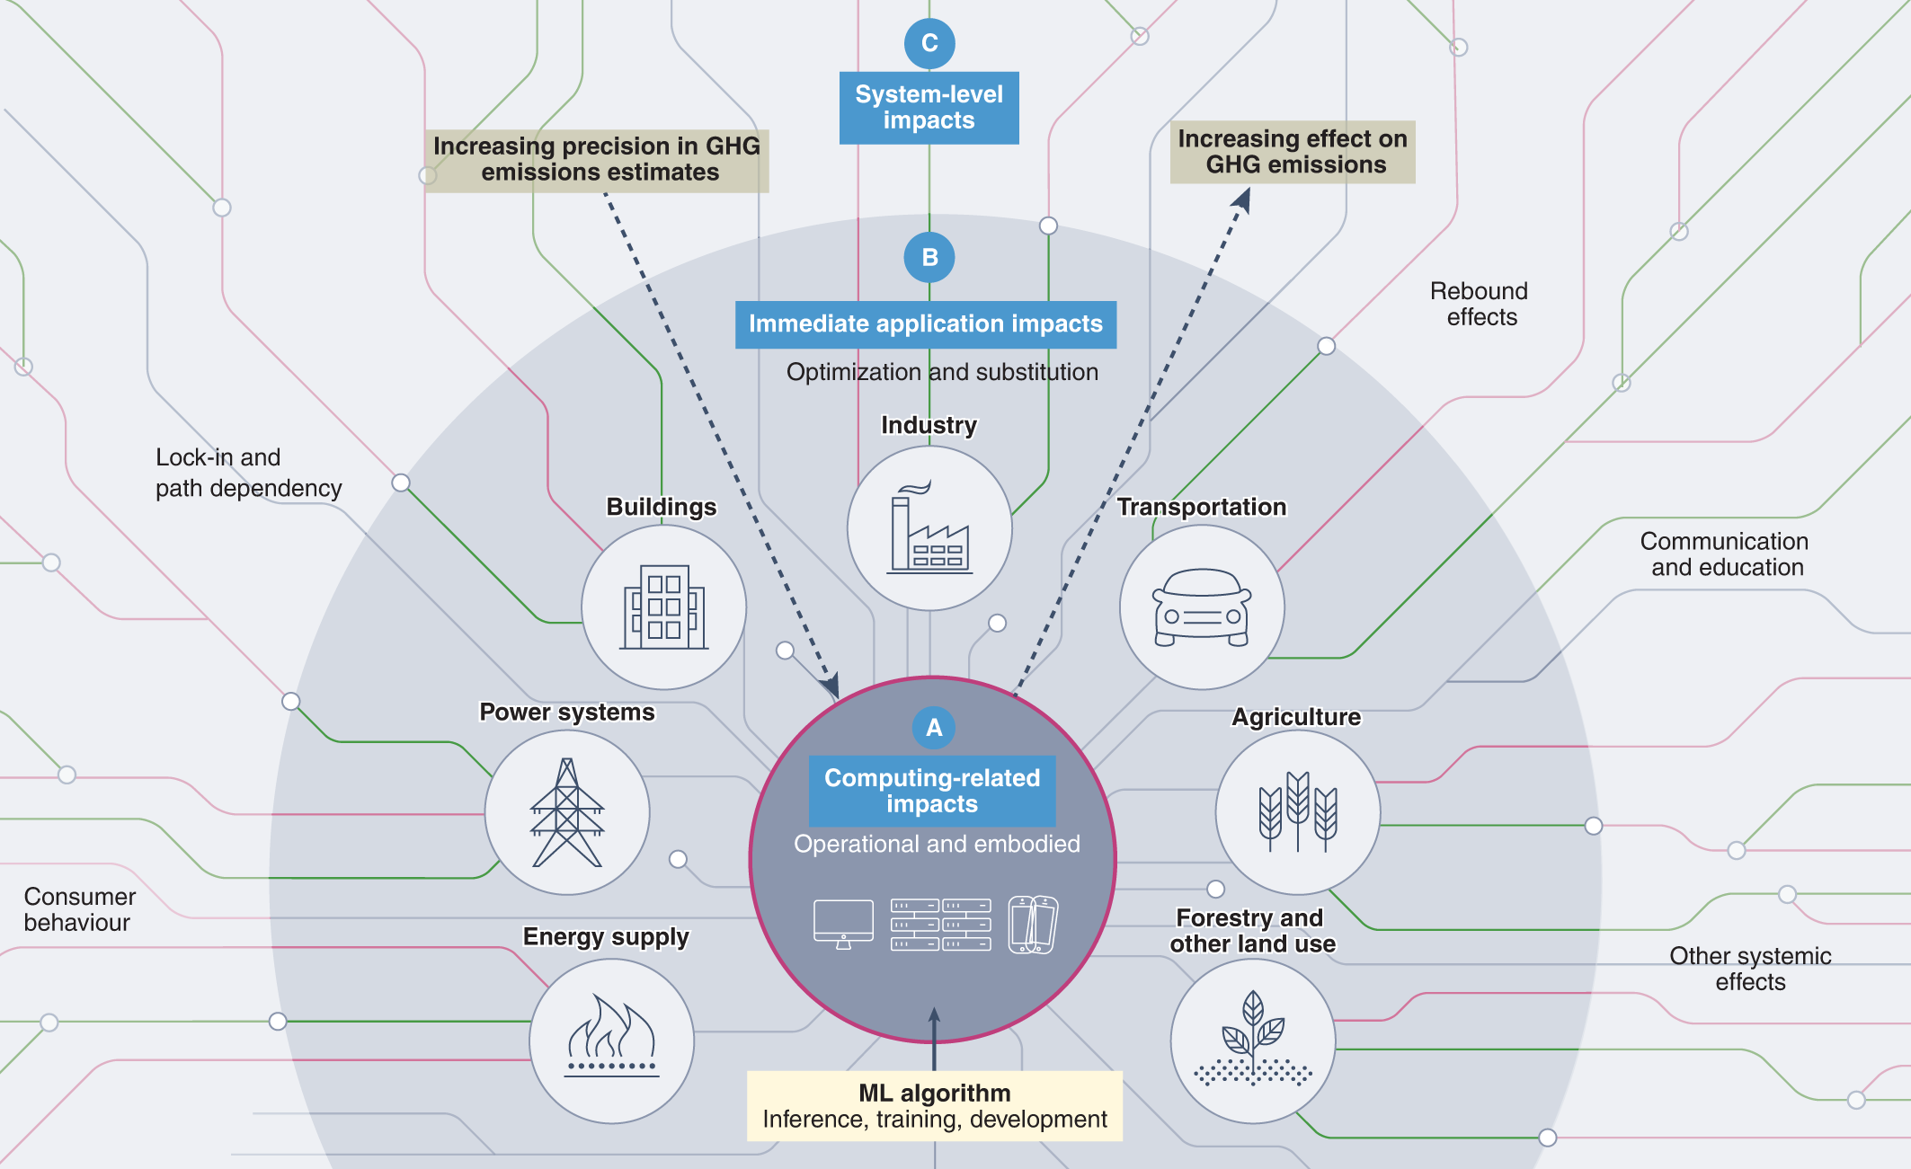
Prerequisite

1 download node.js : Node.js

2 download vs code: Li4nk

3 download metamask : https://metamask.io/

Steps to complete the project

Step 1:-

1. Open the Zip file and download the zip file. Extract all zip files
Step 2 :

1.Open vs code in the left top select open folder. Select extracted file and open .

2. Select the projectname.sol file and copy the code.

3. Open the remix ide platform and create a new file by giving the name of projectname.sol and paste the code which you copied from vs code.

4. Click on solidity compiler and click compile the projectname.sol

5. Deploy the smart contract by clicking on the deploy and run transaction.

6. select injected provider - MetaMask. In environment

7. Click on deploy. Automatically MetaMask will open and give confirmation. You will get a pop up click on ok.

8. In the Deployed contract you can see one address copy the address.

9. Open vs code and search for the connector.js. In contract.js you can paste the address at the bottom of the code. In export const address.

10. Save the code.

Step 3:

open file explorer

1. Open the extracted file and click on the folder.

2. Open src, and search for utiles.

3 . You can see the frontend files. Select all the things at the top in the search bar by clicking alt+ A. Search for cmd
4. Open cmd enter commands npm install
npm bootstrap npm start
5. It will install all the packages and after completing it will open {LOCALHOST IP ADDRESS} copy the address and open it to chrome so you can see the frontend of your project.

